1. Understand the basics.html which was already created

<html>

<body>

<h1>Q1 HTML basics</h1>

<h2>This is heading 1</h2>

<h3>This is heading 2</h3>

<h4>This is heading 3</h4>

<p>My first paragraph.</p>

</body>

</html>

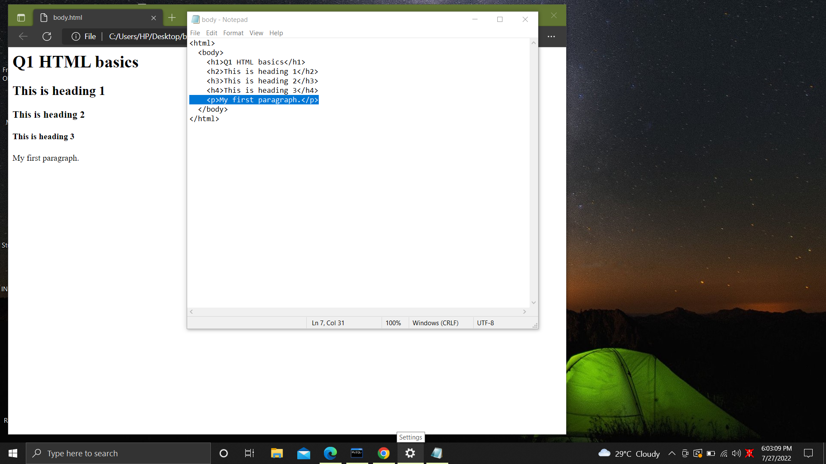

2. Develop your own web page basics.html with all the following html tags

Html, head, title, body

Heading, Paragraph, Italic, Bold, Anchor, Unordered List, List Item, label,

Blockquote, Horizontal rule, Image, Division, Span

<html>

<body>

<h1>Q2 Own webpage with a lot of stuff</h1>

<!--heading-->

<p><b>My first paragraph.</b></p>

<!--paragraph-->

<i>This is my second paragraph</i>

<a href="https://www.youtube.com/watch?v=SSBsDuc_Fas"

>Super serious stuff<!--link-->

</a>

<hr />

<ul>

<li>This is</li>

<li>An Unordered</li>

<!--unordered list-->

<li>List</li>

</ul>

<ol>

<li>this is my favorite song,</li>

<li>it keeps me calm,</li>

<li>and then it also helps me reducing my stress.</li>

</ol>

<blockquote>this is a blockquote</blockquote>

<!--blockqoute-->

<div>This is div block</div>

<!--div-->

<img

src="https://upload.wikimedia.org/wikipedia/commons/f/f9/Phoenicopterus_ruber_in_S%C3%A3o_Paulo_Zoo.jpg"

/><!--image-->

</body>

</html>

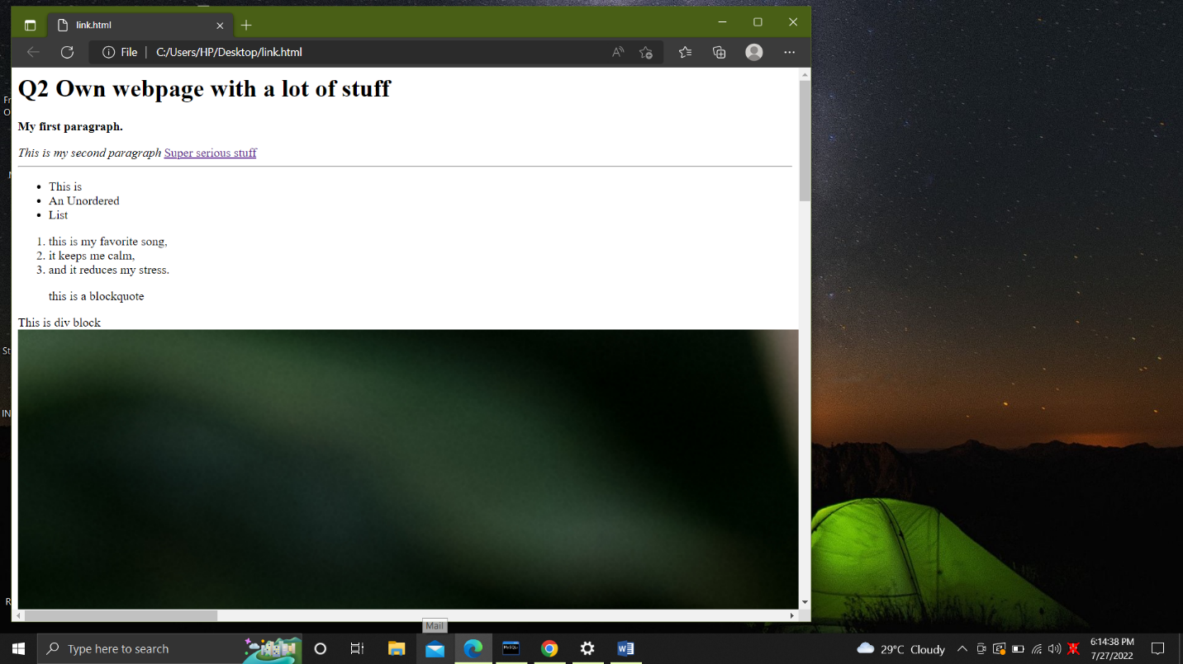

3.Navigate within the page to a different section.

<html lang="en">

<head>

<meta charset="UTF-8" />

<meta http-equiv="X-UA-Compatible" content="IE=edge" />

<meta name="viewport" content="width=device-width, initial-scale=1.0" />

<title>Section links</title>

<style>

* {

margin: 0;

padding: 0;

}

body {

width: 60vw;

height: 160vh;

}

.section {

/*section specifics*/

width: 60vw;

height: 40vh;

background-color: #ef5354;

font-size: 20px;

color: white;

text-align: center;

margin: 5px 5px;

}

.one,

.three {

background-color: #e03b8b;

}

.nav {

/*navigation specifics*/

width: 60vw;

height: 40vh;

background-color: #3944f7;

font-size: x-large;

color: white;

text-align: center;

margin: 5px 5px;

display: flex;

flex-direction: row;

justify-content: space-around;

place-items: center;

}

.btn {

/*button specifics*/

color: white;

background-color: #38cc77;

height: 40px;

width: 90px;

padding: 2px;

border: 2px solid black;

text-decoration: none;

}

</style>

</head>

<body>

<div class="nav">

<a href="#section1" class="btn">1</a>

<a href="#section2" class="btn">2</a>

<a href="#section3" class="btn">3</a>

<a href="#section4" class="btn">4</a>

</div>

<div class="section one" id="section1">section 1</div>

<div class="section two" id="section2">section 2</div>

<div class="section three" id="section3">section 3</div>

<div class="section four" id="section4">section 4</div>

</body>

</html>

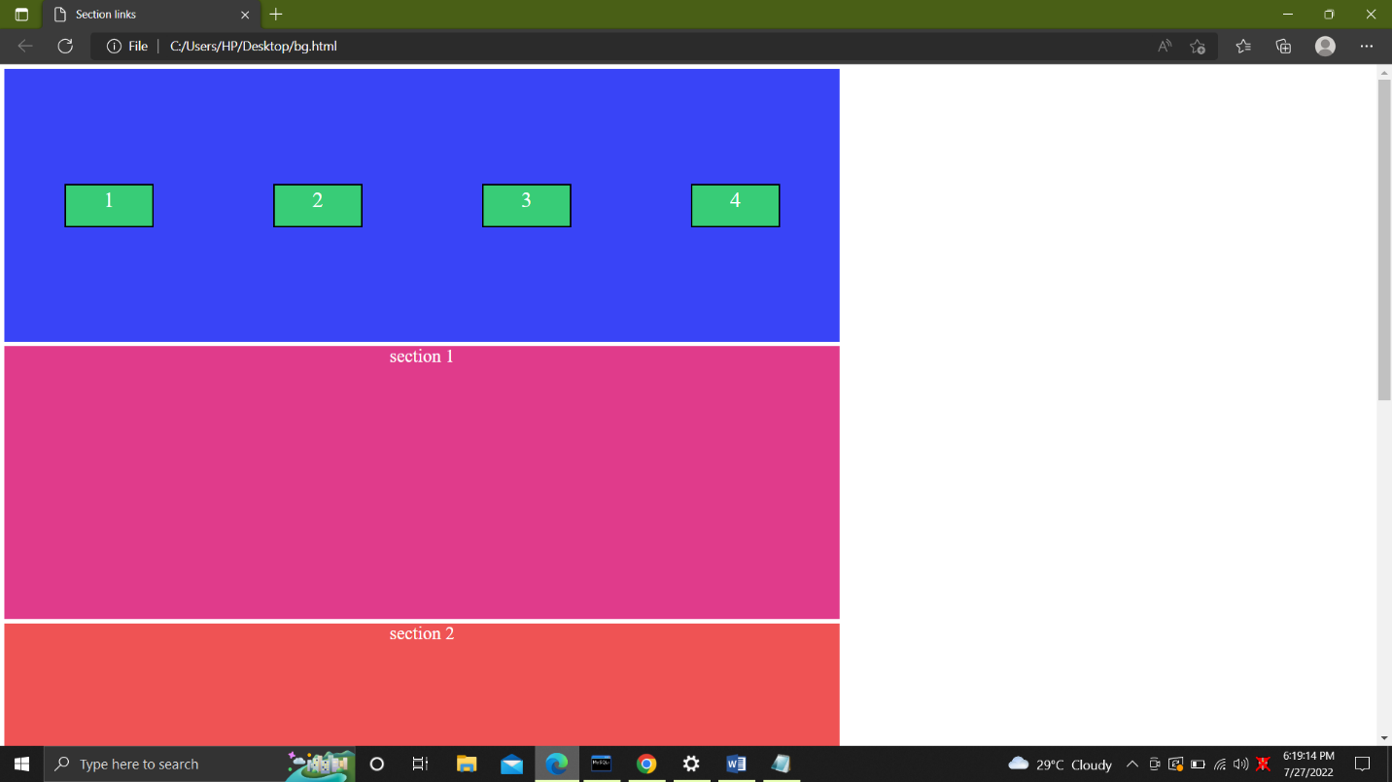

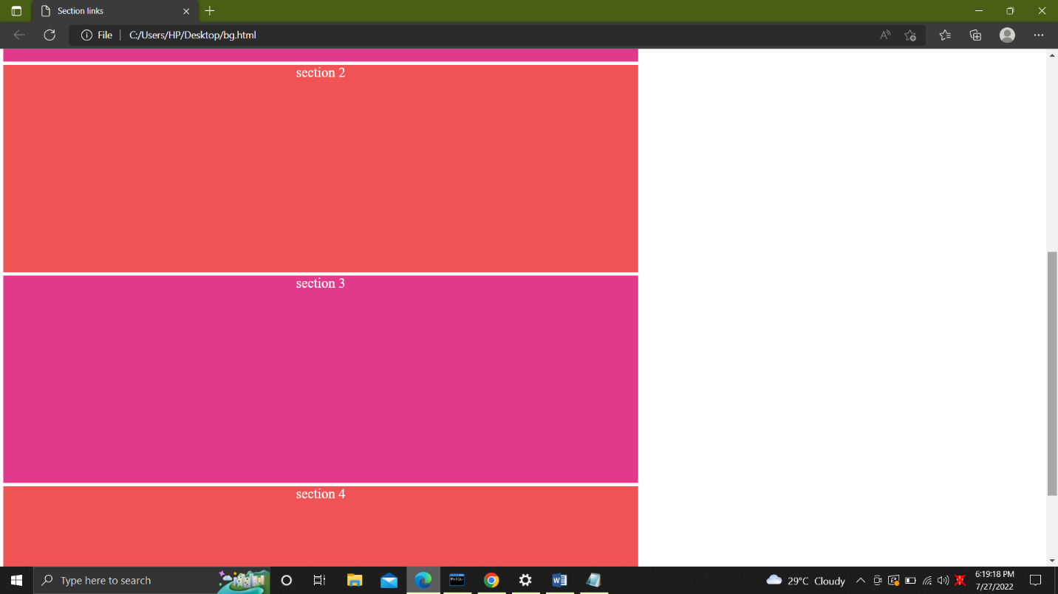

1. Design the web page using all the below input attributes

type =text, password, submit, reset, radio, checkbox, button.

<html lang="en">

<head>

<meta charset="UTF-8" />

<meta http-equiv="X-UA-Compatible" content="IE=edge" />

<meta name="viewport" content="width=device-width, initial-scale=1.0" />

<title>Document</title>

</head>

<body>

<h1>

Using input attributes like text, password, submit, reset, radio,

checkbox, button,

</h1>

<br>

<textarea></textarea>

<textarea rows="4"></textarea>

<textarea rows="4" cols="30"></textarea>

</br>

<br>

<form>

<label for="pwd">Password:</label><!--password input attribute-->

<input type="password" id="pwd" />

</form>

</br>

<br><input type="submit" /></br><!--submit input attribute-->

<br> <input type="reset" /></br><!--rest input attribute-->

<input type="radio" name="gender" id="male" /><!--radio input attribute-->

<label for="male">Male</label>

<input type="radio" name="gender" id="female" />

<label for="female">Female</label>

<label> <input type="checkbox" /> :Bike</label><!--checkbox-->

<label> <input type="checkbox" /> :Car</label>

<button>Button</button><!--button input attribute-->

</body>

</html>

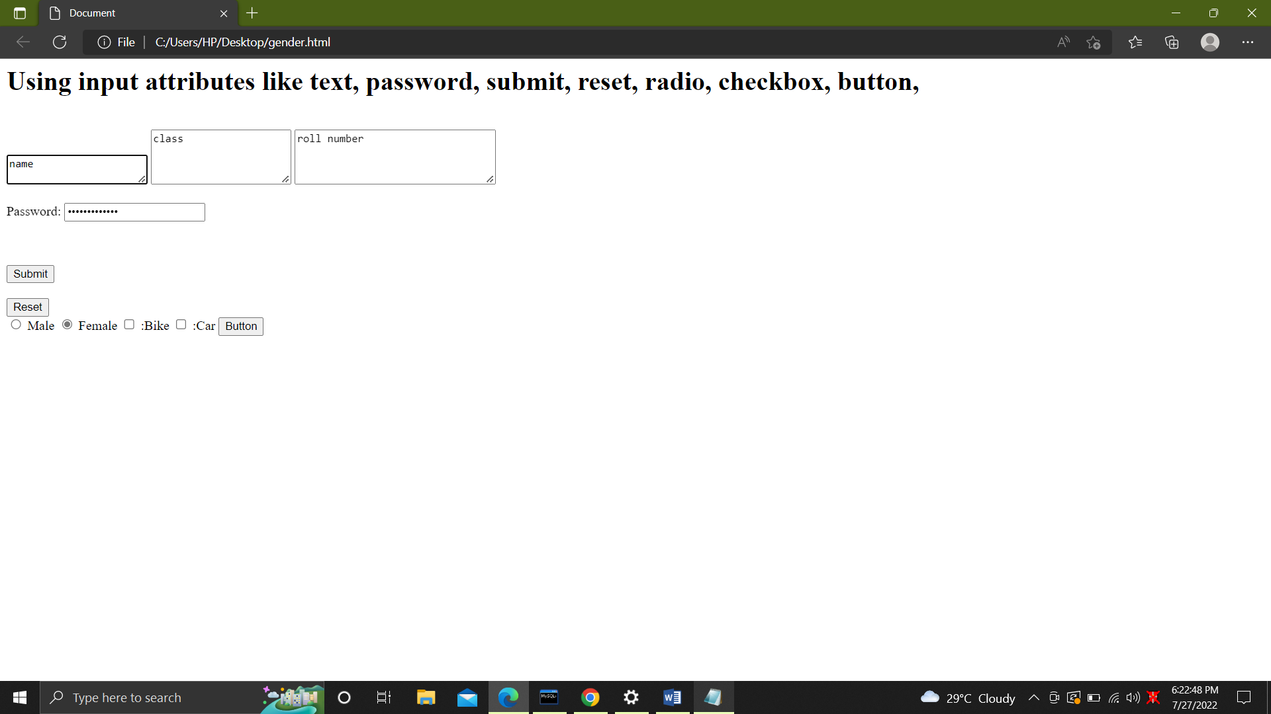

2. HTML5 input Types

type=number, range, color, date, file, time, month, week, email

<html lang="en">

<head>

<meta charset="UTF-8" />

<meta http-equiv="X-UA-Compatible" content="IE=edge" />

<meta name="viewport" content="width=device-width, initial-scale=1.0" />

<title>Document</title>

</head>

<body>

<h1>

Using input attributes like number, range, colour, date, file, time,

month, week, email

</h1>

<form>

<label for="quantity">Quantity (between 1 and 5):</label>

<input

type="number"

id="quantity"

name="quantity"

min="1"

max="5"

/><!--quantity input attribute-->

</form>

<br />

<form>

<label for="vol">Volume (between 0 and 50):</label>

<input

type="range"

id="vol"

name="vol"

min="0"

max="50"

/><!--volume input attribute-->

</form>

<br />

<form>

<label for="favcolor">Select your favorite color:</label

><!--color input type-->

<input type="color" id="favcolor" name="favcolor" />

</form>

<br />

<form>

<label for="birthday">Birthday:</label>

<input

type="date"

id="birthday"

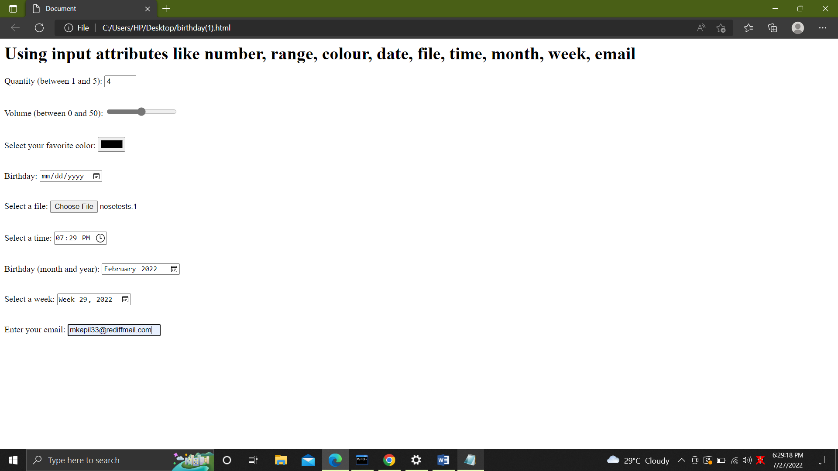

3. Apply all of the below input restrictions

disabled, max, maxlength, min, readonly, required, size, value

<html lang="en">

<head>

<meta charset="UTF-8" />

<meta http-equiv="X-UA-Compatible" content="IE=edge" />

<meta name="viewport" content="width=device-width, initial-scale=1.0" />

<title>Document</title>

</head>

<body>

<h1>

Using input restrictions like disabled, max, maxlength, min, readonly,

required, size, value

</h1>

<form>

<label for="fname">First name:</label><br />

<input type="text" id="fname" name="fname" value="Mansi" disabled /><br />

<label for="lname">Last name:</label><br />

<input type="text" id="lname" name="lname" value="Kapil" />

</form>

<br />

<form>

<label for="datemax">Enter a date before 1980-01-01:</label

><!--max input restriction-->

<input

type="date"

id="datemax"

name="datemax"

max="1979-12-31"

/><br /><br />

<label for="datemin">Enter a date after 2000-01-01:</label

><!--min input restriction-->

<input

type="date"

id="datemin"

name="datemin"

min="2000-01-02"

/><br /><br />

<label for="quantity">Quantity (between 1 and 5):</label>

<input

type="number"

id="quantity"

name="quantity"

min="1"

max="5"

/><!--quantity input restriction-->

</form>

<br />

<form>

<label for="fname">First name:</label

><br /><!--first name input restriction-->

<input type="text" id="fname" name="fname" size="50" /><br />

<label for="pin">PIN:</label><br /><!--pin input restriction-->

<input type="text" id="pin" name="pin" maxlength="4" size="4" />

</form>

<br />

<form>

<label for="fname">First name:</label><br />

<input type="text" id="fname" name="fname" value="John" readonly /><br />

<label for="lname">Last name:</label><br />

<input type="text" id="lname" name="lname" value="Kapil" />

</form>

<br />

<form>

<label for="username">Username:</label

><!--username input restriction-->

<input type="text" id="username" name="username" required />

</form>

<br />

<form>

<label for="fname">First name:</label><br />

<input type="text" id="fname" name="fname" size="50" /><br />

<label for="pin">PIN:</label><br />

<input type="text" id="pin" name="pin" size="4" />

</form>

<br />

<form>

<label for="fname">First name:</label><br />

<input type="text" id="fname" name="fname" value="Mansi" /><br />

<label for="lname">Last name:</label><br />

<input type="text" id="lname" name="lname" value="Kapil" />

</form>

</body>

</html>

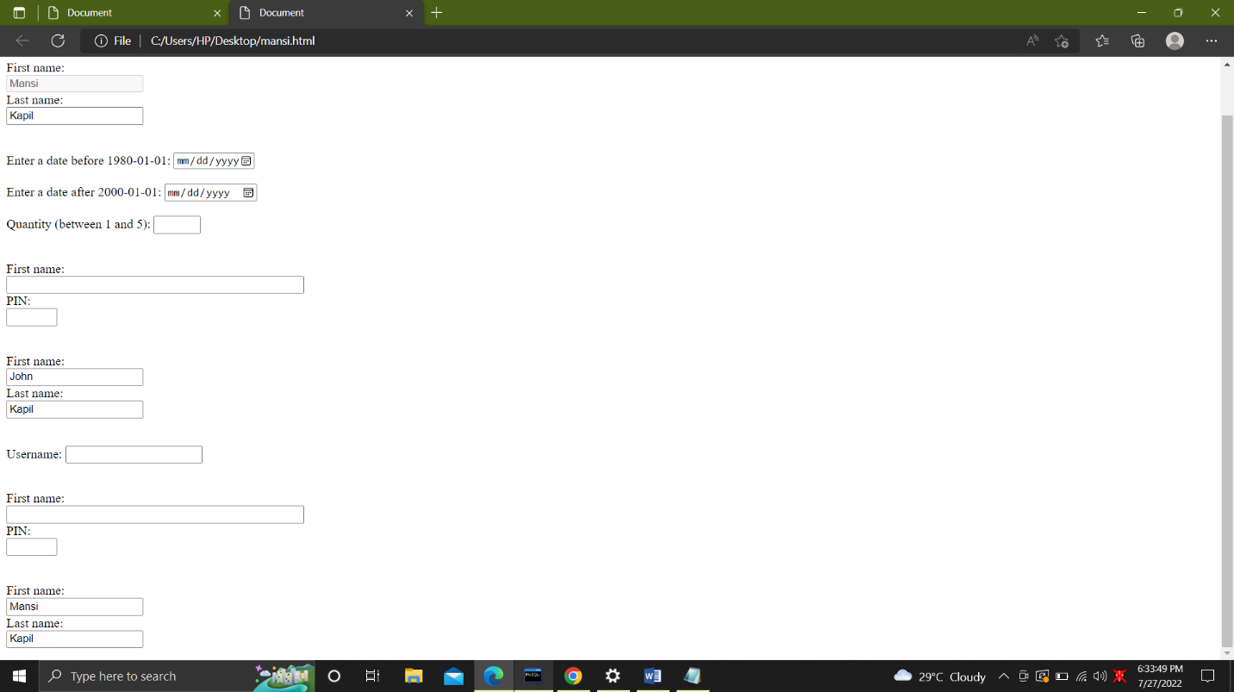

4. Develop a web page usin<html>

<head>

<meta charset="UTF-8" />

<meta http-equiv="X-UA-Compatible" content="IE=edge" />

<meta name="viewport" content="width=device-width, initial-scale=1.0" />

<title>Document</title>

</head>

<h1>Target Attribute</h1>

<body>

<a href="https://jalatechnologies.com/" target="_blank">Visit JALA TECH</a

><!--this is the target attribute it works like a link-->

</body>

</html>g target attribute

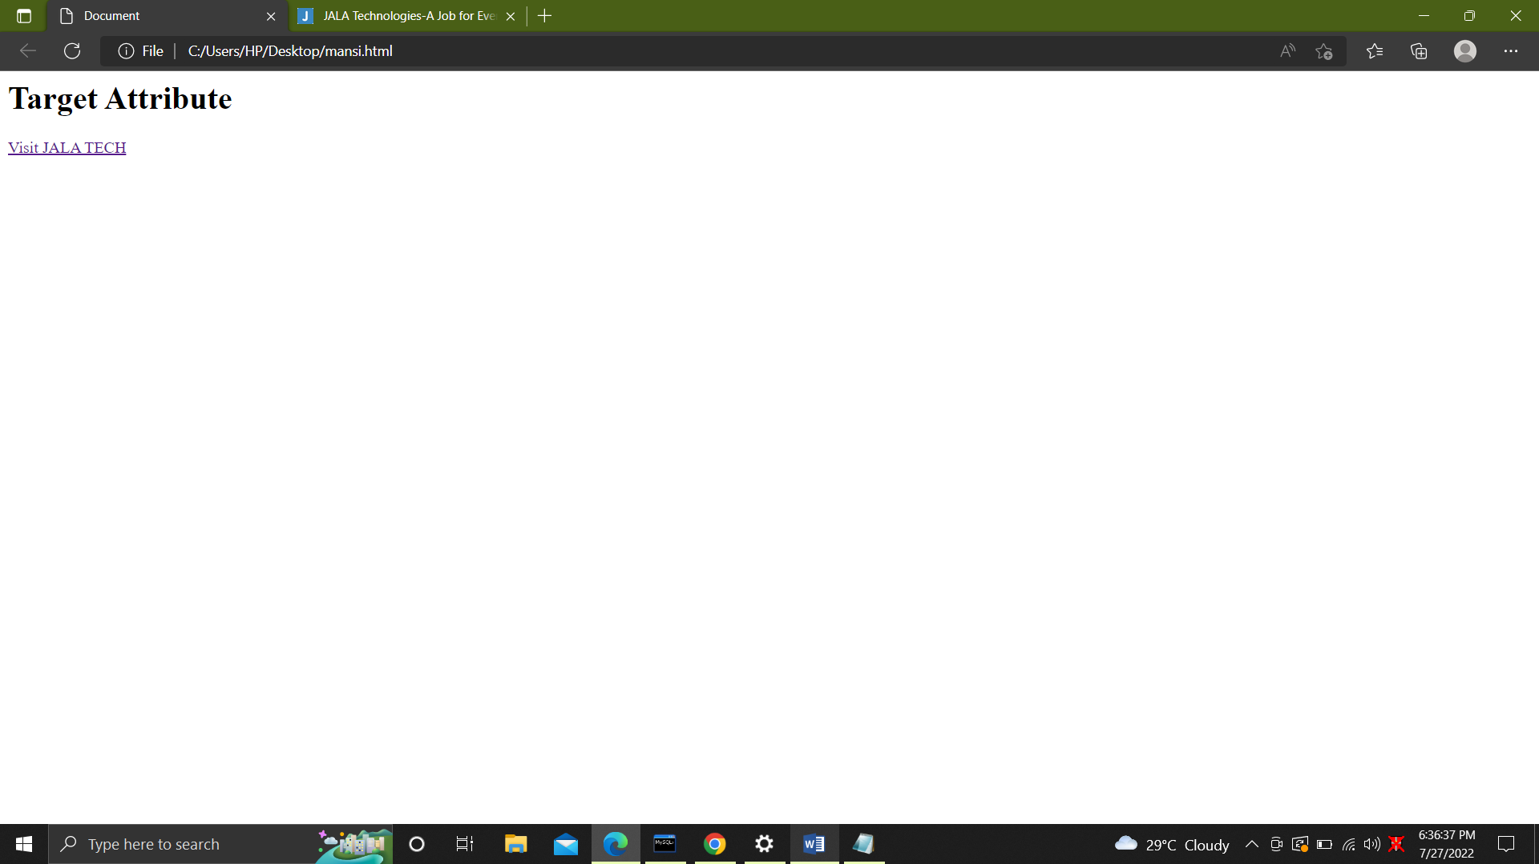



5. -Use I-frames and Marquee in your webpage

<html>

<body>

<h1>iframe and marquee</h1>

<iframe src="https://jalatechnologies.com" title="A job for everyone"

><!--this is the iframe-->

</iframe>

<marquee>This is a basic marquee</marquee

><!-- this is the marquee-->

</body>

</html>

Develop a web page with non-semantic elements <div> and <span>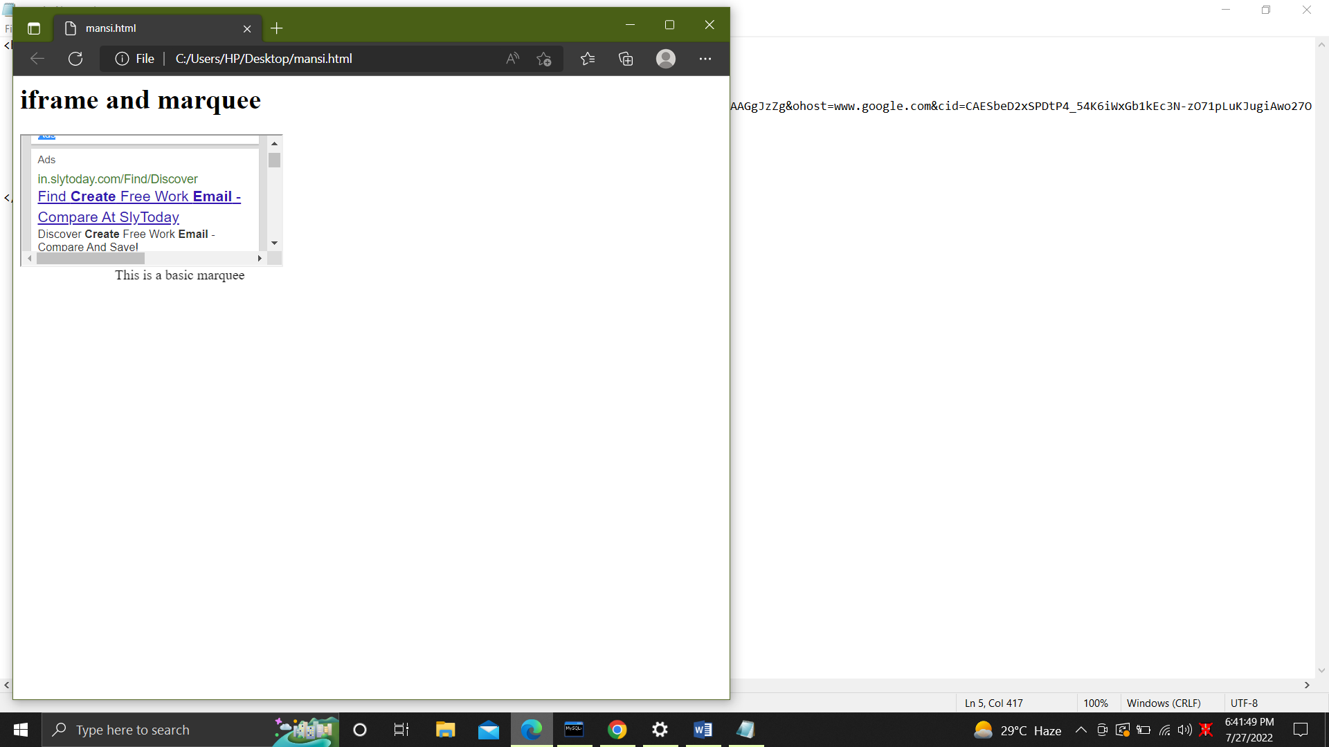

1. Develop a web page with non-semantic elements <div> and <span>

<html>

<head>

<title>Div tag</title>

<style>

div {

color: white;

background-color: #009900;

margin: 2px;

font-size: 25px;

}

</style>

</head>

<body>

<div>it wont take time</div>

<div>do your best</div>

<div>be proud of yourself</div>

<h2>This is span tag it won't take the whole line</h2>

<p>

<span style="background-color: pink"> Lorem, ipsum.</span> you will be proud of yourself

.<span style="color: red"

><!--this the the span block-->

you</span

>

you will be <span style="background-color: lightblue">articles</span>

stop overreactingfor the things you dont care about.

</p>

</body>

</html>

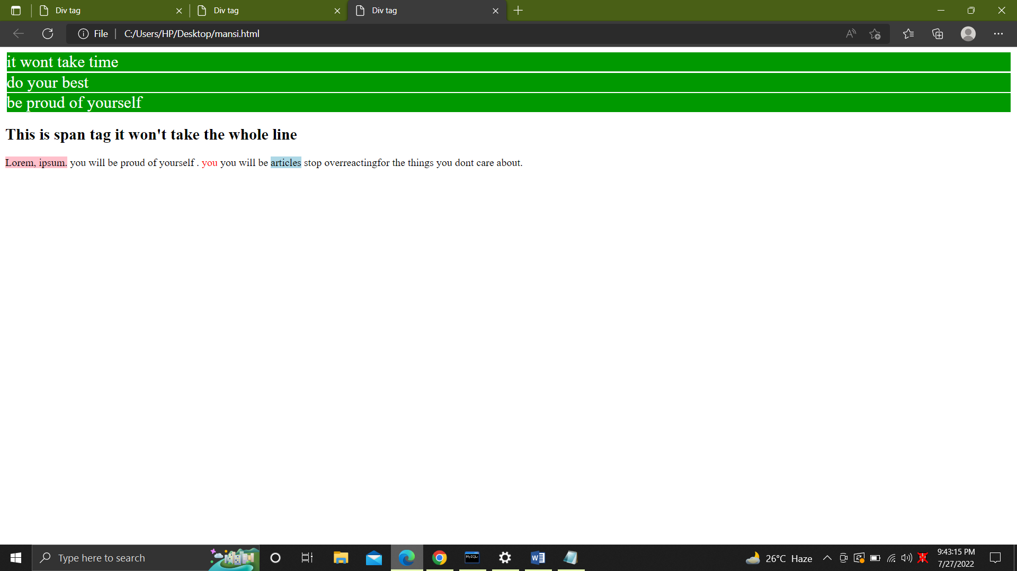

1. Develop a web page with the semantic elements <form>, <table> and <article>

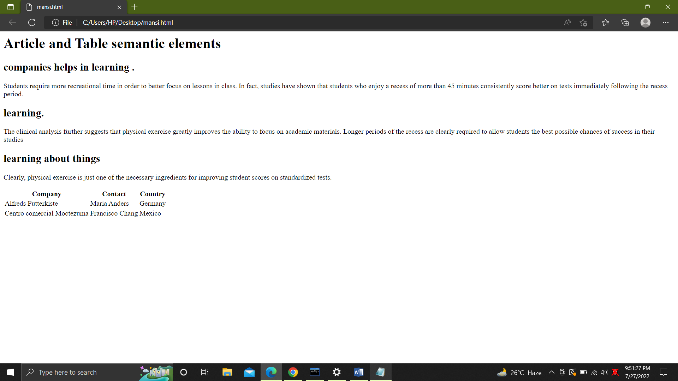

3. Use all the HTML5 tags and develop a web page

article, aside, figcaption, figure,footer,header, hgroup,mark,nav, section,time.

<html>

<head>

<meta charset="UTF-8" />

<meta http-equiv="X-UA-Compatible" content="IE=edge" />

<meta name="viewport" content="width=device-width, initial-scale=1.0" />

<title>Document</title>

</head>

<body>

<section>

<p>Top Stories</p>

<section>

<p>News</p>

<article>World Council of Credit Unions (WOCCU) announced Diana Dykstra,

CEO of the California and Nevada Credit Union Leagues (USA),

as its new Board Chair on day three of the 2022 World Credit Union Conference.

</article>

<article>oung credit union professionals from across the globe finally got the in-person recognition they deserved for WYCUP scholarships

awarded in 2020 and 2021 during the final general session of the 2022 World Credit Union Conference.</article>

<article>GLASGOW, Scotland—World Council of Credit Unions (WOCCU) on Monday presented awards for digital growth

and credit union service during its Annual General Meeting (AGM) at the 2022 World Credit Union Conference.

</article>

</section>

<section>

<p>Sport</p>

<article>IND vs WI: Shubman Gill sharpens his ODI game.</article>

<article>The Indian hand behind 'English' weightlifter: Once homeless and suicidal, an asylum seeker becomes England's medal hope.</article>

<article>India beat Windies by 119 runs in 3rd ODI, takes series 3-0.</article>

</section>

</section>

<br />

<aside>

<p>

This is a sidebar, for example a terminology definition or a short

background to a historical figure.

</p>

</aside>

<figure>

<img

src="https://en.wikipedia.org/wiki/File:Shadow_of_Mordor_cover_art.jpg"

alt="Shadow of Mordor"

/>

<figcaption>Cover art for Middle-earth: Shadow of Mordor</figcaption>

</figure>

<footer>&copy;Company A</footer>

<header>

<h1>Company A</h1>

<ul>

<li><a href="/home">Home</a></li>

<li><a href="/about">About</a></li>

<li><a href="/contact">Contact us</a></li>

</ul>

<form target="/search">

<input name="q" type="search" />

<input type="submit" />

</form>

</header>

<hgroup>

<h1>Heading 1</h1>

<h2>Subheading 1</h2>

<h2>Subheading 2</h2>

</hgroup>

<nav>

<ul>

<li><a href="/home">Home</a></li>

<li><a href="/about">About</a></li>

<li><a href="/contact">Contact us</a></li>

</ul>

</nav>

<time datetime="2017-10-31T11:21:00+02:00">Tuesday, 31 October 2017</time>

</body>

</html>

